OpenCDS Developer Workstation Configuration Instructions

Last updated November 3, 2010 by Kensaku Kawamoto, MD, PhD

- Version History
  - 10/3/2010
    - Initial creation by Kensaku Kawamoto, based on source documentation created by David Shields
      - Eclipse Configuration for OpenCds.doc
      - Installing Drools on Tomcat.docx
      - Installing JBoss Drools Plugin for Eclipse.docx
  - 11/3/2010
    - Updated reference to Drools version for Maven installation to 5.1.1 instead of 5.1.0
Note: these instructions are based on a Windows XP 32-bit machine

Installation and Setup of Infrastructure Components

- Install Java
  - Install Java SE SDK version 6 or above
    - For these instructions, downloaded SE SDK 6 Update 21 from http://www.oracle.com/technetwork/java/javase/downloads/index.html, as jdk-6u21-windows-i586.exe
    - Run executable, install using default options
      - Default installation directory for JRE is C:\Program Files\Java\jre6, which also creates directory for SDK at C:\Program Files\Java\jdk1.6.0_21; use of these directories are assumed in directions below

  - Install Java EE SDK version 6 or above
    - For these instructions, downloaded EE SDK 6 Update 1 from http://www.oracle.com/technetwork/java/javaee/overview/index.html
    - Download the “Java EE 6 SDK” version (shown below) as java_ee_sdk-6u1-jdk-windows.exe
    - Note that this download includes GlassFish 3.0.1, which we are not using for OpenCDS. Therefore, GlassFish installation instructions are intentionally not provided.
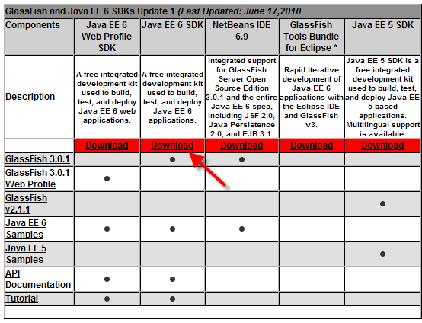
    - Run executable, install using default options, except as noted below
      - Instead of default installation directory of C:\glassfishv3, use C:\Program Files\Java\jdkee6; use of this directory is assumed in directions below

- Install Maven
  - Download .zip file of latest stable Maven build from http://maven.apache.org/download.html
    - These instructions used Maven version 2.2.1 at http://www.apache.org/dyn/closer.cgi/maven/binaries/apache-maven-2.2.1-bin.zip
    - Unzip archive
    - Follow instructions in README.txt, provided below
    - Directory specifications below are not mandatory, but recommended for consistency purposes
      - Place unzipped folder (apache-maven-2.2.1) in following directory: C:\Program Files\Apache Software Foundation
    - Control Panel → System → Advanced → Environment Variables → System Variables
      - Set MAVEN_HOME to “C:\Program Files\Apache Software Foundation\apache-maven-2.2.1”
      - Add %MAVEN_HOME%\bin to Path
        - In this example, was added to beginning of Path
      - Set JAVA_HOME to Java SE SDK location
        - E.g., C:\Program Files\Java\jdk1.6.0_21
    - Test it by typing into a command prompt mvn --version (note there are two dashes before “version”) and it should show something similar to this:
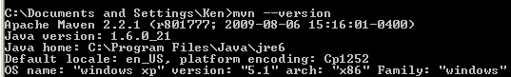

- Install Tortoise SVN
  - Download from http://tortoisesvn.net/downloads
  - Version used for this example is 1.6.10
  - Install using default options
  - Restart machine

- Install Tomcat 6
  - Download “32-bit/64-bit Windows Service Installer” from http://tomcat.apache.org/download-60.cgi
  - Accept defaults
    - Install it at default location of “C:\Program Files\Apache Software Foundation\Tomcat 6.0” to be compatible with other Duke uses of Tomcat, many of which have hard-coded paths to that location.
  - Set Tomcat Administrator Login to something secure
  - Control Panel → System → Advanced → Environment Variables → System Variables
      - Set CATALINA_HOME to, e.g., “C:\Program Files\Apache Software Foundation\Tomcat 6.0”
      - Add %CATALINA_HOME%\bin to Path
        - In this example, was added to beginning of Path
- Install latest stable version of Eclipse
  - From http://www.eclipse.org/downloads/

  - Select 32 or 64-bit version
  - Unzip it directly into C:\Program Files where it will create a directory named Eclipse
  - Notes
    - You do not need to modify your path or add environment variables to use eclipse
    - You may want to add a shortcut for it on your quick-start bar, or in your start menu. You may also want to give it more memory to work with (see eclipse help)
    - Read the release notes (especially if you have problems) found at C:\Program Files\eclipse\readme\readme_eclipse.html
    - Remember that you can often fix weird problems in eclipse from a command prompt by entering “eclipse –clean” which will start eclipse with a clean slate
  - When first starting Eclipse, set workspace to appropriate directory
    - Suggested location is “C:\OpenCDS”

- Install Eclipse plugins
Eclipse has built-in tools to locate and install plug-ins, and to update them when necessary. Use the built-in tools whenever possible. This is done by going to
Help → Install New Software

  - Install M2Eclipse
    - Help → Install New Software
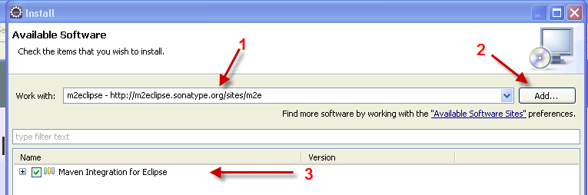

Type the name and URL (1) after clicking the Add button (2), and you should then click in the box beside “Maven Integration for Eclipse (3), and click the Next button at the bottom of the Install window.

It will verify your selection (making sure dependencies are present), and then give you a chance to go back to add dependencies, or continue by clicking Next.

Accept the license and click Finish

- Alternatively, you may find M2Eclipse on the Help | Eclipse Marketplace | Recent menu, and do the whole process with a single click.

If you get the following warning, click OK to ignore.
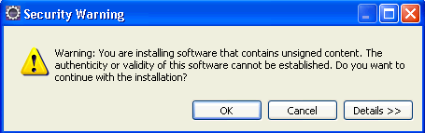

  - Install Subclipse
    - Help → Eclipse Marketplace
    - Subclipse → Install
    - Do either of the following (depending on whether you intend to use Mylyn):
      - Don’t install Subclipse Integration for Mylyn 3.x, but install everything else
      - Install all
    - → Finish

  - Configure Subclipse
    - Window → Show View → Other → SVN → SVN Repositories
    - Configure SVN repositories
      - http://develop.opencds.org/SVN
    - Now, can check out projects from SVN

- Alternatively, you may find Subclipse on the Help | Eclipse Marketplace | Popular menu, and do the whole process with a single click.

  - Make sure Eclipse is pointed to a JDK rather than a JRE in Eclipse Preferences
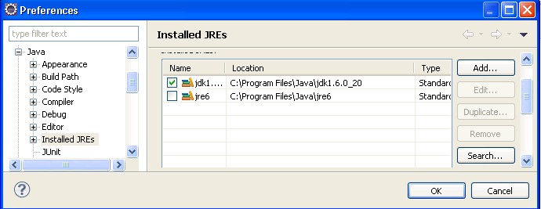

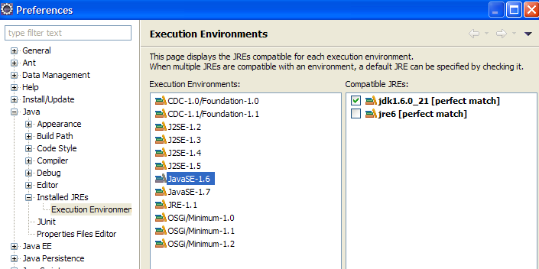

  - Set Eclipse Preferences for Subversion
    - Window → Preferences → Team → SVN
    - Menu icons → Tortoise SVN

  - Set up Tomcat Server in Eclipse
    - File → New → Other → Server 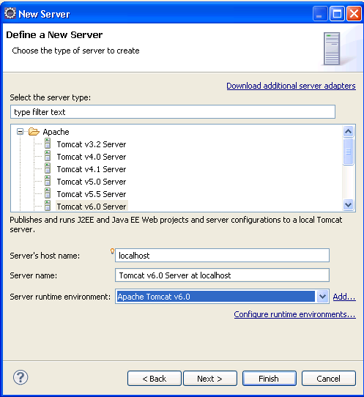
    - Select installation directory, Finish
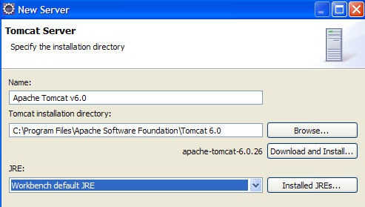

  - Set Eclipse to use JDK instead of JRE, also increase maximum memory allocation
    - Add to C:\Program Files\eclipse\eclipse.ini boldfaced item below, per http://tech.karolzielinski.com/m2eclipse-eclipse-is-running-in-a-jre-but-a-jdk-is-required
    - E.g.,

-startup
plugins/org.eclipse.equinox.launcher_1.1.0.v20100507.jar
--launcher.library
plugins/org.eclipse.equinox.launcher.win32.win32.x86_1.1.1.R36x_v20100810
-product
org.eclipse.epp.package.jee.product
--launcher.defaultAction
openFile
--launcher.XXMaxPermSize
256M
-showsplash
org.eclipse.platform
--launcher.XXMaxPermSize
256m
--launcher.defaultAction
openFile

-vm
C:\Program Files\Java\jdk1.6.0_21\jre\bin

-vmargs
-Dosgi.requiredJavaVersion=1.5
-Xms40m
-Xmx900m
  - → Alternatively, you can add the following to the command line when you run eclipse (put it in a shortcut so you don’t have to type it every time.). This allows you to create different Eclipse configurations as separate icons for different purposes:
-vm “C:\Program Files\Java\jdk1.6.0_21\jre\bin” -vmargs -Xmx900m

  - Set Eclipse Preferences for Maven
    - Window → Preferences → Maven → Installations → Add → specify Maven root folder (e.g., C:\Program Files\Apache Software Foundation\apache-maven-2.2.1) → OK
    - Create a settings.xml file in location specified in Eclipse:

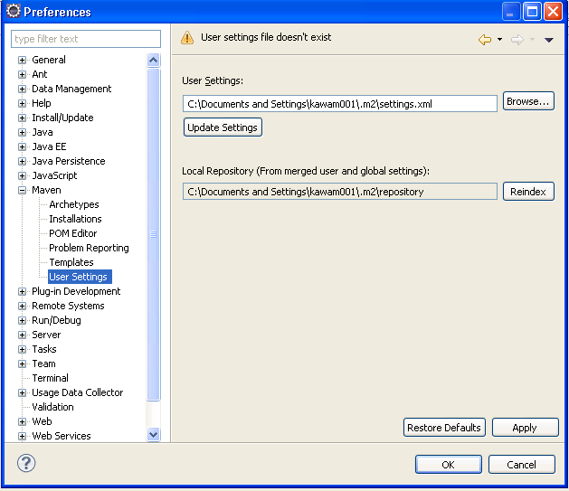

    - Sample XML:
<?xml version="1.0" encoding="UTF-8"?>
<settings xmlns="http://maven.apache.org/SETTINGS/1.0.0" xmlns:xsi="http://www.w3.org/2001/XMLSchema-instance" xsi:schemaLocation="http://maven.apache.org/SETTINGS/1.0.0 http://maven.apache.org/xsd/settings-1.0.0.xsd">
<pluginGroups>
</pluginGroups>
<proxies>
</proxies>
<servers>
</servers>
<mirrors>
</mirrors>
<profiles>
</profiles>
</settings>

  - Install Jboss Drools Eclipse 3.5 Workbench (allows writing rules and working with Drools Flow, and testing / debugging directly from Eclipse). Use either of the following procedures:
    - Manual installation
      - Download the file named Drools Eclipse 3.5 Workbench from http://www.jboss.org/drools/downloads.html
      - Unziip the file into a temporary folder somewhere
      - Copy the contents of the “features” directory to C:\Program Files\eclipse\features
      - Copy the contents of the “plugins” directory to C:\Program Files\eclipse\plugins
      - Restart Eclipse
    - Automatic installation from Eclipse
      - Download Drools plugin for Eclipse
        - Help → Install New Software
        - http://downloads.jboss.com/drools/updatesite3.5/

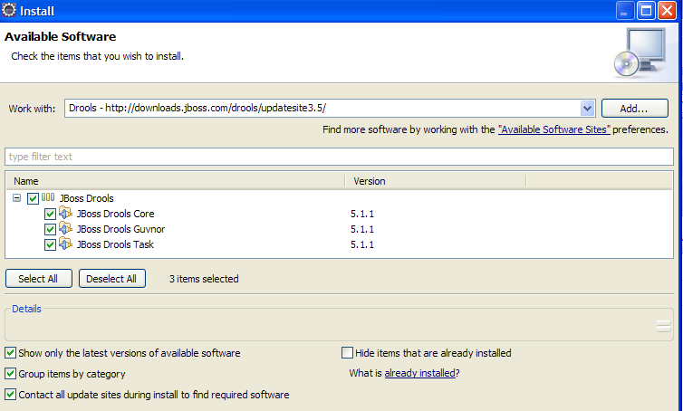

      - Configure Drools Eclipse 3.5 Workbench
        - Open the Eclipse Preferences, and then open the tab named Drools
        - Leave all settings at defaults, except the following
          - The tab named Installed Drools Runtime must point to an available location (eg, C:\Drools511) where you will place all the Drools binary files for Drools 5.1.1. E.g.,
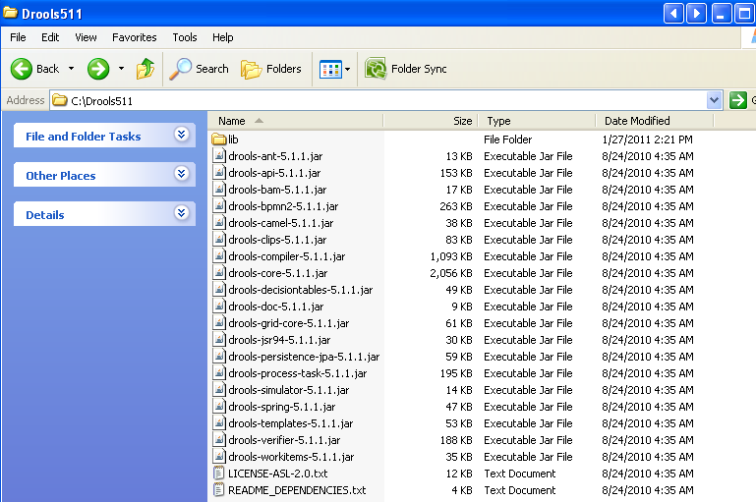

          - Select the version of Drools (since you are allowed to have more than one installed) that you want to add to the build path of newly created Drools projects.

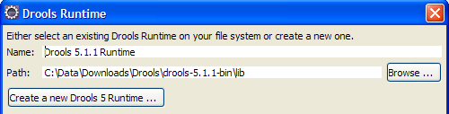

  - Download the Drools Runtime version 5.1.1
    - Download file named Drools Binaries from http://www.jboss.org/drools/downloads.html
    - Unzip the file into a temporary folder somewhere
    - Copy all the jar files to the location you specified in the previous step (eg, C:\Drools511 or C:\Data\Downloads\Drools\drools-5.1.1-bin\lib as shown on screenshot directly above)

OpenCDS Configuration in Eclipse

Both of the projects below are imported in the same way. The first one is a Maven parent for the 5 dependent Eclipse projects, which are included in the one Subversion project as dependent Maven Modules. Both of these projects are in Subversion, and all modules implement some aspect of the OMG Decision Support Service specification, or the HL7 vMR specification.

- opencds-parent (contains only the POM file for Maven to define all the dependencies for the project, including the following 5 modules)
  - opencds-drools-service (work in progress, adapter with interfaces to DSS web services and to Drools, packaged as WAR file)
  - opencds-vmr-internal (work in progress, basic java beans with support for mapping data in from vmr-external, and mapping results out to vmr-external, packaged as JAR file which is used by both opencds-drools-service, and separately by Drools Guvnor for KnowledgeBase authoring)
  - opencds-vmr-external (data classes generated by JAXB from vMR schema, which is included in project, packaged as JAR file)
  - opencds-common (utilities, vocabulary, and simplified datatypes based on ISO 21090 datatypes, found in vmr-external, and mapped in and out of vmr-internal, packaged as JAR file used by both OpenCDS Drools Service, and separately by Drools Guvnor)
  - dss-java-stub (stable, OMG DSS v.1 base code, packaged as JAR file)
- dss-wsdl-2-java (closed project – do not build – for archival purposes only)
  - closed project, is run once when there are changes to the standard OMG DSS wsdl,
  - flat java package is then manually adjusted to final hierarchical package structure,
  - the final package structure is then manually copied to project dss-java-stub as a dependency for the basic operation of DSS
  - WARNING: rebuilding this project will overwrite the existing manually adjusted package structure, which will take a day or two to rework…

- Import Projects into Eclipse
  - File → Import
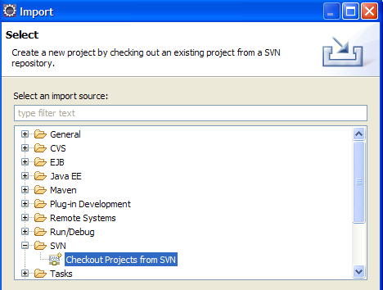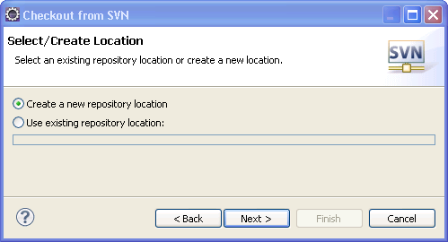

Set location of repository to http://develop.opencds.org/svn

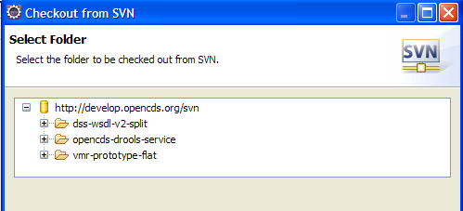

  - Import projects in the following order
  - dss-wsdl-v2-split
  - vmr-prototype-flat (work in progress)
  - opencds-drools-service (work in progress)
  - Details for the SVN import:

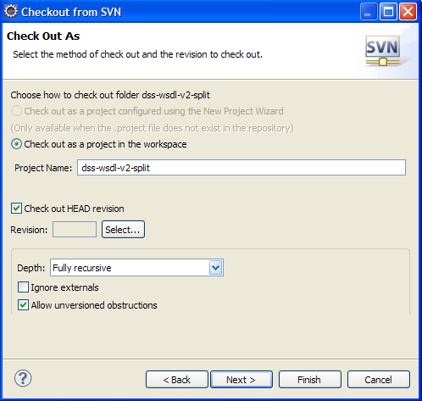

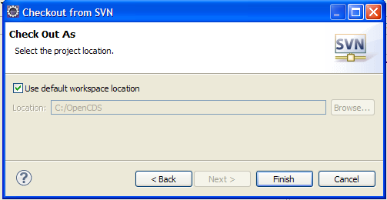

- Download and install Drools 5.1.1 jars into local Maven repository
  - Go to http://www.jboss.org/drools/downloads.html
  - Download Drools binaries at http://download.jboss.org/drools/release/5.1.1.34858.FINAL/drools-5.1.1-bin.zip
  - Unzip binary
  - Install required Drools binaries into local Maven repository using following script from command line, after updating source path to where the unzipped files are located:

mvn install:install-file -Dfile="C:\Data\Downloads\Drools\drools-5.1.1-bin\drools-api-5.1.1.jar" -DgroupId=org.drools -DartifactId=drools-api -Dversion=5.1.1 -Dpackaging=jar

mvn install:install-file -Dfile="C:\Data\Downloads\Drools\drools-5.1.1-bin\drools-core-5.1.1.jar" -DgroupId=org.drools -DartifactId=drools-core -Dversion=5.1.1 -Dpackaging=jar

mvn install:install-file -Dfile="C:\Data\Downloads\Drools\drools-5.1.1-bin\drools-compiler-5.1.1.jar" -DgroupId=org.drools -DartifactId=drools-compiler -Dversion=5.1.1 -Dpackaging=jar

mvn install:install-file -Dfile="C:\Data\Downloads\Drools\drools-5.1.1-bin\drools-decisiontables-5.1.1.jar" -DgroupId=org.drools -DartifactId=drools-decisiontables -Dversion=5.1.1 -Dpackaging=jar

- Download Drools plugin for Eclipse
  - Help → Install New Software
  - http://downloads.jboss.com/drools/updatesite3.5/

- Establish Eclipse Drools runtime
  - Windows → Preferences → Drools → Installed Drools Runtime → Add
    - E.g. (use particular folder where Drools runtime jar was unpacked):

Drools Guvnor Configuration

- Download Drools Guvnor 5.1.1 war file from JBoss
  - Download from http://download.jboss.org/drools/release/5.1.1.34858.FINAL/drools-5.1.1-guvnor.war
    - note: a version with the JBoss App Server is also available at http://download.jboss.org/drools/release/5.1.1.34858.FINAL/drools-5.1.1-guvnor-standalone.zip. However, since we will be using Tomcat, you do not need to download this version.
  - Place war file in Tomcat webapps directory (e.g., C:\Program Files\Apache Software Foundation\Tomcat 6.0\webapps)
  - Start Tomcat (e.g., through Control Panel → Administrative Tools → Services

- Verify installation
  - Go to http://localhost:8080/drools-5.1.1-guvnor/org.drools.guvnor.Guvnor/Guvnor.html
  - Login as “”, “”
  - Upload latest OpenCDS implementation via Import feature

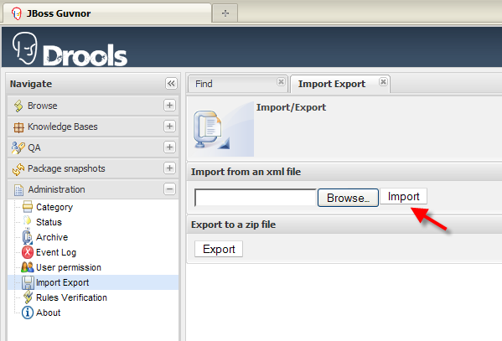

Note: this instruction needs to be placed within the Drools service installation instructions later.

- Download and install Spring Source jar into local Maven repository
  - Go to http://s9.springsource.com/repository/app/bundle/version/detail;jsessionid=82BA09CA7A21166C5DC4B67427FAD708.jvm1?name=com.springsource.org.apache.jasper.springsource&version=6.0.20.S2-r5956
  - Download binary at http://s9.springsource.com/repository/app/bundle/version/download?name=com.springsource.org.apache.jasper.springsource&version=6.0.20.S2-r5956&type=binary
  - Install binary into local Maven repository using following script from command line, after updating source path to where the unzipped files are located:

mvn install:install-file -Dfile=" C:\Downloads\com.springsource.org.apache.jasper.springsource-6.0.20.S2-r5956.jar" -DgroupId=org.apache.jasper.springsource -DartifactId=com.springsource.org.apache.jasper.org.eclipse.jdt.springsource -Dversion=6.0.20.S2-r5956 -Dpackaging=jar
Apelon Configuration in Eclipse

- Add information on Apelon Maven repository in POM file, from http://sourceforge.net/apps/mediawiki/apelon-dts/index.php?title=DTS_3.5_API_Development_with_Maven
- Directions below assume using SQL Server 2008:
  - Edit POM file so that the SQL Server JDBC referenced is:
    - <dependency>
    - <groupId>com.microsoft.sqlserver</groupId>
    - <artifactId>sqljdbc</artifactId>
    - <version>3.0</version>
    - <scope>runtime</scope>
    - </dependency>
    - <dependency>
  - Download SQL Server 3.0 JDBC from http://www.microsoft.com/downloads/en/details.aspx?FamilyID=a737000d-68d0-4531-b65d-da0f2a735707&displaylang=en
  - Unzip archive, install the sqljdbc4.jar into local Maven repository doing following from command line, after updating source path to where the unzipped files are located:

mvn install:install-file -DgroupId=com.microsoft.sqlserver -DartifactId=sqljdbc -Dversion=3.0 -Dpackaging=jar -Dfile="C:\Data\Downloads\SQL Server 2008 JDBC Driver\Microsoft SQL Server JDBC Driver 3.0\sqljdbc_3.0\enu\sqljdbc4.jar"

Guvnor Configuration

- Put following jars in lib directory of drools-guvnor Webapp folder
